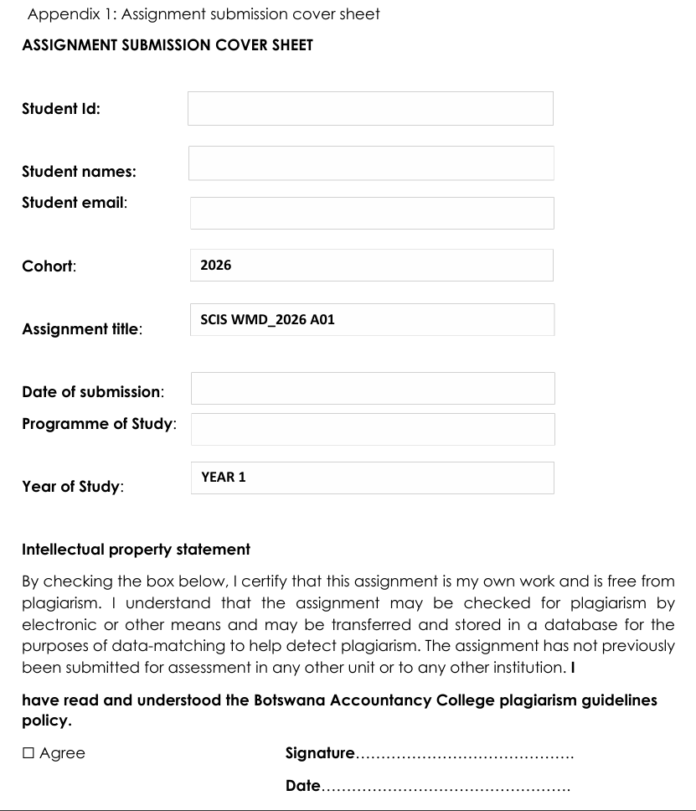
Computer Systems Engineering
Cse25-320@thuto.bac.ac.bw
Bame Molefe
Cse25-320
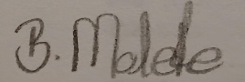

CREATING A WEBSITE FOR MOLEFE WILD TRAILS
PART A
1. REQUIREMENTS AND SPECIFICATIONS
*Client Requirements
-Information about game animals and activities available at the game park
-Images of animals
-A website that is easy to use on both phones and computers
-Promotion of Molefe Wild Trails
-Available food at the park
-Available activities at the park
*Project Specifications
The main mission of this website is to promote Molefe Wild Trails as the best tourist destination by providing clear and attention grabbing information about its wildlife and activities done there. The aim is to attract both international and local tourists and educate them on nature awareness and the beauty of the park.
#Audience definition
The target audience for this website is people who love nature and game and are interested in visiting Molefe Wild Trails including researchers in wildlife, students on school excursions, wildlife enthusiasts, local and international tourists.
Users of this website:
-People between the ages of 16 and 60
-Have basic computer skills
-Use smartphones, tablets or computers to browse the internet
-Are interested in animals and outdoor activities
User needs:
-Get information about Molefe Wild Trails
-View pictures of available game animals and attractions
-Get information about activities done at the park
-Payment plans
-Pricelist for activities done at the park
User Aptitude:
-Familiar with using websites
-Can easily navigate through the website menus
*Technical Requirements
The website will developed using HTML, CSS and BootStrap. It will require a computer, excellent internet connection and different web browsers for testing. The website will be hosted using GitHub pages and will be designed to be compatible with multiple browsers and different devices.
2. INFORMATION DESIGN AND TAXONOMY CREATION
Site Map:
-Home Page>Introduction to Molefe Wild Trails and a brief overview of the park
-About us>The park’s mission and vision and it’s story
-Wildlife>Images of the animals available, short descriptions of each animal
-Activities>Available activities and their descriptions
-Gallery>Images and videos of animals, landscapes and tourist activities
-Contact us>Park email, phone number and social media links
-Feedback>Form for users to leave comments and rate their experience
Home Page
^{Comment Form}
Feedback
Contact us
Gallery
Activities
Wildlife
About us
^{Email}
^{Animal Images}
^{Game viewing}
^{Wildlife Images}
^{Mission and Vision}
^{Our Story}
^{Rating System}
^{Phone /Telephone number}
^{Animal Videos}
^{Hiking Trails}
^{Landscape Images}
^{Bird Watching}
^{Wildlife Descriptions}
^{Social media links}
^{Guided Tours}
^{Tourist activity videos}

3. GRAPHIC DESIGN AND PAGE TEMPLATE CREATION
A wireframe will be created with the following features:
-Nature themed colours
-Wildlife images
-Navigation menu
-A consistent layout across all pages

4. CONSTRUCTION AND CONTENT DEVELOPMENT
Technical development:
The website code is written using HTML, CSS and Bootstrap
Editor used- Visual Studio Code
5. QUALITY ASSURANCE AND USER TESTING
Conduct the following:
-Checking if all links are working
-Test if the website works on different browsers and devices
-Gathering feedback from users to improve usability
-Identify and fix errors
6. PUBLISHING AND PROMOTION
*Upload the website on GitHub
*Connect the domain name to make the website live
*Promote the website through social media by sharing the link to the website
*Encourage site visitors to engage using contact forms

7. ONGOING MAINTENANCE
-Fix technical issues and broken links
-Add new features to the website eg online booking and multilingual support
-User experience improvements

